RONALD MOSS
Oct 24, 2021 at 4:47 PM

Think About What You Think


"There is a mistaken idea, ancient but still with us, that an overdose of anything from fornication to hot chocolate will teach restraint by the very results of its abuse." ~ M. F. K. Fisher

Consider This...
There will never be enough drugs. The brain's capacity to learn and adapt is basically unfathomable, and, as is always the case with addictive drugs, tolerance spoils the fun.
Think about this statement as you engage in the discussion. Make sure you follow "The Discussion Instructions."

The Prompt
In the United States, almost 50,000 people died of a drug overdose in 2019. However, in 2020, drug overdose deaths reached a new all-time high of more than 93,000. The majority of these deaths involved prescription pain relievers and heroin.
The scourge that is opioid addiction has exploded, the numbers show that the opioid epidemic knows no boundaries. Once a plague affecting primarily the poor and destitute, heroin addiction is claiming a new subset of victims that cuts across race, class and socioeconomic status. These are new addicts who were drawn into heroin use by prescription painkillers. Current opioid overdoses are mostly white; many are affluent, but the working class and poor white, black, and brown, communities are being negatively impacted as well.
The transition to heroin is a phenomenon that is occurring more rapidly than we've ever seen before, and heroin laced with Fentanyl has become commonplace. Fentanyl is a synthetic opioid that is 100 times more potent than heroin or morphine. According to the CDC, after just five days of use, the risk of addiction increases drastically. Further, Purdue Pharmaceuticals engaged in the aggressive marketing of OxyContin. There is an obvious reason large quantities of opioids are circulating in homes and communities across the country. Since the mid-1990s, people from all walks of life have become hooked on prescription painkillers, from overprescribing highly addictive opioids, marketed to treat chronic pain.
By far, the United States consumes more opioidsthan any other country. The Chief Clinical Officer at Recovery Centers of America, Deni Carise, sees it this way: It used to be people seeking treatment for heroin addiction had a decade or more of illicit drug use. What we’re seeing now is people who haven't done any illegal drugs and don’t know anything about the lifestyle, are going from being drug naïve to prescription drug use to heroin addiction in six to eight months. Because opioid addiction is no respecter of person nor any race, class, ethnicity, or culture, the opioid crisis is cutting across all socioeconomic barriers.

The Discussion Instructions
- Read "The U.S. Opioid Epidemic" article here.
- Watch the "Free Heroin, Cocaine & Meth Are Being Distributed to Stop Overdoses" here.
- Referencing the readings in the prompt, the video, anything relevant in your COSER textbook(s), and other resources, discuss the history of the opioid epidemic and your personal and / or professional perspective(s) on, and insight(s) into, the affect of opioids on society.
- Do you agree with the free drug program in Vancouver as a proper public health harm reduction strategy? Why? Why not?
- This is a 400 word assignment worth 50 points. In order to receive full credit, you must respond to both 3 and 4 and be thorough.

Note:

  - See the 50 point discussion rubric (in rubric link on the navigation bar) for grading criteria.
  - You must submit a post BEFORE you can see your classmates posts.
  - Ideally, your response to your classmates should consist of a complete thought that contributes to the dialogue and furthers the discussion.
  - There are no right or wrong responses, so share your knowledge, insights and thoughts freely,
  - Please be respectful to one another as you explore and discuss your id

Think

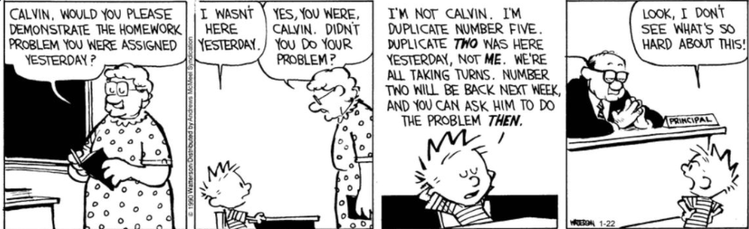
“The individual does actually carry on a double existence: one designed to serve his own purposes and another as a link in a chain, in which he serves against, or at any rate without, any volition of his own.” ~ Sigmund Freud

Food for Thought...
Focus on the light in the darkness. Focus on the joys in the pain. Focus on the strength in the weakness. Life's totality is duality. All bad ain't bad and some good will come with pain. The suffering comes from what we choose to focus on. Feel. Process. Release. And then...Focus.
Think about this statement as you complete the rest of the assignment. Make sure you follow "The Discussion Instructions."

The Prompt
Comorbidity substance abuse problems and mental health issues are more common than many people realize. To make the situation more complicated, co-occurring disorders also affect each other According to the Journal of the American Medical Association, approximately 50 percent of individuals with a severe mental disorder are affected by substance abuse. Conversely, about half of people with a substance use disorder have a co-occurring mental health issue also. Oftentimes, when comorbid and mental health issue develop, substance use issues follow, usually as form of self-medication. When the mental health issue goes untreated, the substance abuse problem usually gets worse, and when alcohol and drug use increases, mental health problems usually increase too. We know comorbidity between substance use and mental health issues can cause or make existing mental health issues worse; however, it is also true that, in some cases, substance use issues and mental health issues can stem from a common cause. Clearly, the relationship between mental illness and substance use. are deeply complex, so anyone seeking help for substance abuse should also be screened for a co-occurring mental health issue. There is still much to learn, but if recovery from a substance use disorder is to have a chance at being successful, co-occurring issues of substance abuse and mental health challenges need to be identified early and treated concurrently.

The Discussion Instructions
- Watch the "Substance Abuse, Alcoholism, and Co-occurring Disorders" video here.
- Referencing the video, your textbook, and other resources, discuss the similarities between substance use disorders and mental health disorders that make it difficult to diagnose a client who is demonstrating comorbid symptoms.
- Which mental disorder(s) are most often mistaken for a substance use disorder? Why?
- Your submission word count is 300 - 500 words.

Note:

  - You must submit a post BEFORE you can see your classmates posts.
  - Your replies to your classmates should consist of a complete thought that contributes to the dialogue and furthers the discussion. "I agree" or "I like what you said" does not meet this criteria.
  - There are no right or wrong responses, so share your knowledge, insights and thoughts freely, but please be respectful to one another as you explore and discuss your ideas.
  - See the discussion rubric (in rubric link on the navigation bar) f

24, 2021 at 4:50 PM

Think About What You Think Og high pop I

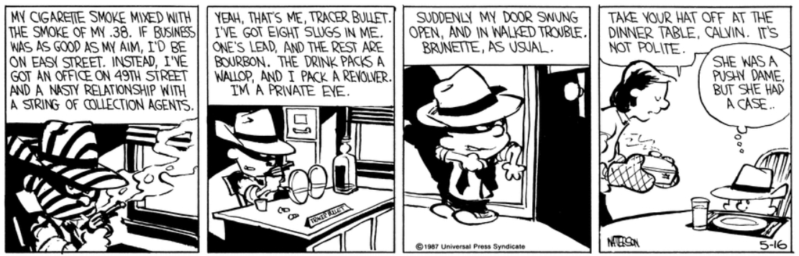
“The pendulum of the mind alternates between sense and nonsense, not between right and wrong.” ~ Carl Jung

A Word to the Wise...
Be aware of unhealthy patterns of interaction. There is room to disrupt unhealthy cycles and create healthier ones.
Think about this statement as you complete the rest of the assignment. Make sure you follow "The Discussion Instructions."

The Prompt
The goal of a psychological evaluation is to establish whether a mental disorder or other conditions require the attention of a mental health professional. During an evaluation, sufficient data must be collected in order to support a diagnosis; develop a treatment plan; and identify longer-term issues that may require follow-up care. The evaluation explores psychiatric, medical, social, and developmental history, prior psychiatric assessments, treatments, and the client's adherence to past treatments. With substance abusing clients, the psychological testing process investigates the addiction history and substance(s) abused. Conditions such as chronic pain and insomnia may fuel addiction. Attempts should made to gain a broader perspective on client's personality by reviewing this / her responses to significant recent and past life events. Clients struggling with by

often neglect the comorbid conditions, ranging from blood pressure to diabetes. To determine whether there is a need for mental health and other services, a complete, objective picture is obtained during the evaluation process. Individuals with an addiction or suspected of having an addiction may also have neurological conditions that impact their behavior. A comprehensive psychological evaluation and assessment evaluates all of the conditions that can compromise health and well-being.

The Instructions
- Watch the "Psychological Assessment" video here.
- Referencing the video, your textbook, and other resources, explain what a psychological evaluation is.
- What is the purpose of a psychological evaluation?
- Reference your source(s) of information in your reply.
- Respond to at least two of your classmates.
- Word count is 300 - 500 words.

Note:
- You must submit a post BEFORE you can see your classmates posts.
- Ideally, your response to your classmates should consist of a complete thought that contributes to the dialogue and furthers the discussion.
- There are no right or wrong responses, so share your knowledge, insights and thoughts freely, but please be respectful to one another as you explore and discuss your ideas.
- See the discussion rubric (in rubric link on the navigation bar) for grading criteria.
- Your discussion submission is due on Sunday, October 31, 2021 at 11:59pm.

Consider

Think About What You Think
"...I'd say one of the great lessons I've learned over the past couple of decades, from a management perspective, is that really when you come down to it, it really is all about people and all about leadership." ~ Steve Case

Consider This...
In the helping professions, we contribute to each other’s success; however, as case managers we play a special role in supporting the ongoing wellbeing of our clients.
Think about this question as you complete the rest of the assignment. Make sure you follow "The Assignment Instructions."

The Prompt
All case data is stored in a case file. A case file is used in case management to store data for the entire case. As soon as you have a new client or a new case the first order of business is to organize the case file. To make things easier, you can use an intake form at the first meetingitself to gather the required information and use it to create the case file. When you begin organizing cases files right at the start, you learn to see what is missing or needs updating more easily. What’s more, using a common system ensures that cases are always filed using the same format all the time, which makes it easy for other employees of the organization with permission to access the file. Ultimately, clear and concise documentation benefits the case a manager because most questions and ambiguity can be eliminated. When you have a long list of things to do and many cases to manage, prioritizing tasks according to their importance ensures that you can comfortably give your attention to the case that needs your focus and care at the appointed time. Case files can a hardcopy and /or electronic, but electronic filing systems are becoming the industry standard.

The Assignment Instructions
- Watch the "ENG | Module 5: Information Management for Case Management" here.
- Referencing the videos, your textbook (pgs. 275-283), and other resources discuss what components make up a case file and importance of creating comprehensive and thorough case files.

Your Response
- Your response should be a minimum of two paragraphs.
- The assignment due date is Sunday, October 31, 2021 at 11:59 pm.

Click the Next ▶ button

Think About What You Think


“Calling it lunacy makes it easier to explain away the things we don't understand.” ~ Megan Chance

Food for Thought...
Addicts are often stigmatized as undeserving but are never associated with the underserved who are being discriminated against.
Think about this statement as you complete the rest of the assignment. Make sure you follow "The Assignment Instructions."

The Prompt
Stigma has been described as a mark of disgrace associated with a particular person or circumstance. In the context of co-occurring psychiatric and substance use disorders, only a limited amount literature has focused on stigma. Nevertheless, clients with either a psychiatric illness, a substance use disorder, and / or both are subject to stigma. Stigma creates barriers that result in the client's reluctance to seek and participate in treatment services. Another affect of stigmatization is the fear of discrimination in psychiatric treatment, especially in emergency settings and environments where negative stereotyping is involved. Since it often results in isolation and discrimination, the stigma of substance abuse and mental illness can reduce the social support for clients, which impedes the client's reintegration into mainstream society. We know there is a high prevalence of substance use among persons with psychiatric disordersand vice versa, which makes providing adequate services quite challenging. These difficulties often result in the overuse of emergency medical and psychiatric services.

The Instructions
- Watch the ANTHR - Stigma Towards Co-Occurring Disorders here.
- Referencing the video, anything relevant in the chapter 25 reading, and other resources, discuss how stigma towards individuals with a co-occurring disorder will make it difficult for your client to access and successfully complete treatment services for his / her dual diagnosis.
- When addressing stigma and avoiding harming your client, what is the best way to refer to his / her disorder(s)?

Your Assignment Response
- For this assignment, your response should be a minimum of two complete paragraphs.
- The assignment due date is Sunday, October 31, 2021 at 11:59 pm

